Proposed Solution
The proposed solution describes the complete system developed to predict motor temperature using machine learning techniques.
3.1 Solution Overview
The system collects real-time and historical motor operational data, processes it using machine learning models, and predicts motor temperature. Based on predictions, alerts are generated to notify users of potential overheating conditions.

3.2 Key Components of the Proposed Solution
- Sensor data acquisition
- Data preprocessing and feature engineering
- Machine learning model training and prediction
- Visualization and alert mechanism

3.3 Functional Workflow
- Motor operational data is collected from sensors
- Data is cleaned and preprocessed
- Trained ML model predicts motor temperature
- Predicted values are displayed on the dashboard
- Alerts are generated if predicted temperature exceeds safe limits

3.4 Expected Outcomes
- Early detection of overheating
- Reduced motor failures
- Optimized maintenance scheduling
- Improved operational efficiency
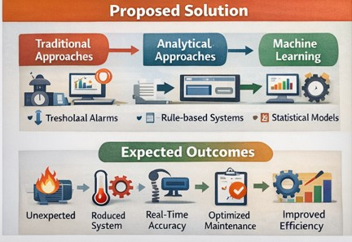

3.5 Benefits of the Proposed Solution
- Predictive rather than reactive monitoring
- Cost-effective maintenance
- Improved motor lifespan
- Enhanced safety and reliability

